جامعـة العلـوم التطبيقية الخاصة  كلية تكنولوجيا المعلومات  الواجب الأول - 02312    Student Name: Musaab Alfalahi  Student ID: 202020329  □ CS □ SE |  | APPLIED SCIENCE UNIVERSITY (ASU)  FACULTY OF INFORMATION TECHNOLOGY (FIT)  Assignmnet-1 2023-1  Subject: Software Development and Documentation  Instructor: Dr. Jalal Kiswani  Due Date: 25/ 11/ 2023
- What are the differences between waterfall and agile approaches in software engineering? (1 Mark)

Waterfall: linear and sequential methodology where the development process is divided into distinct phases, Each phase must be completed before progressing to the next, and changes are challenging to incorporate once a phase is finished.

Agile: iterative and incremental methodology that emphasizes adaptability and collaboration. It breaks the project into small iterations or sprints. The focus is on delivering working software quickly and responding to changing requirements efficiently.

- What are the most commonly used UML diagrams in the requirements phase? model an example of each one of them. (2 Marks).

- Context diagram:
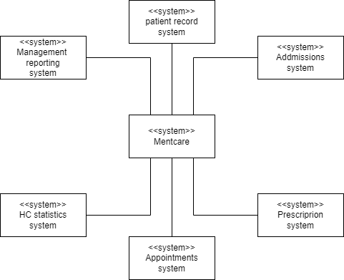

- Use Case diagram:
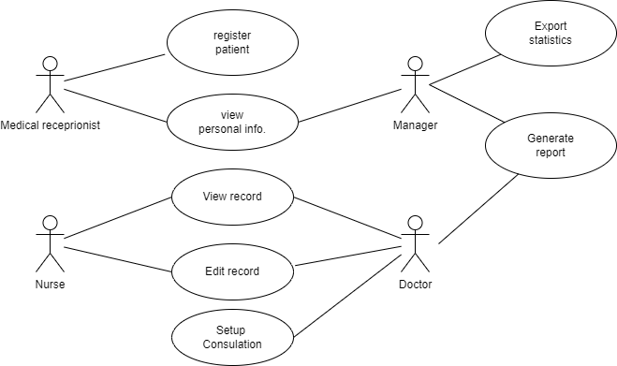

- Please draw a conceptual data model of a system that consists at least of 3 entities with min of three attribiutes per entity(2 Marks).

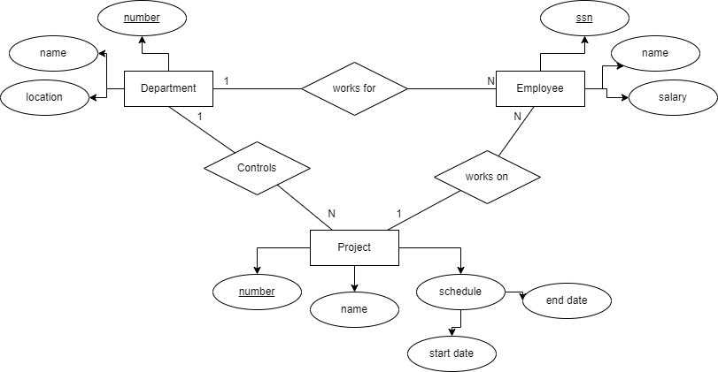

(5 marks)

Instructions and Notes:
- This is an individual assignment. Any two identical answers will be graded ZERO automatically.
- Please submit your answer in.pdf format.
- You will be asked to EXPLAIN what you have submitted and your project will be evaluated on this basis
- Assignments submitted AFTER DUE DATE WILL NOT BE ACCEPTED.

Good Luck ☺

